|  |
| --- |
|  |
| EE-436L Database Engineering |
|  |
| Project Report |

**Zain Mujahid (2016-EE-304)**

**Samiullah Arshad (2016-EE-276)**

**Fatimah Lyba Khan (2016-EE-342)**

**Annas Bin Malik (2016-EE-337)**

June 15, 2020

EE-436L Database Engineering

Project Report

# Introduction

Pharmacies are essential component of healthcare in the Pakistan and handle the function of selling medical drugs. Even though the pharmacies do not seem different than any other shop, their functioning is very different due to various laws regarding drugs.

For example, most of the drugs available in a pharmacy cannot be purchased without a prescription. Even with a signed prescription, there is a limit on the quantity that can be purchased. Additionally, pharmacist can do a background check on customer’s medical history to ensure that they are not involved in drug abuse.

In addition, there are other laws on the operations of pharmacy like requirement for safe disposal of expired medicine and requirement of license for employees that mix/prepare the drugs.

Thus, preparing a Database Management System for a pharmacy not only requires study of how things are handled from a customer or employee point of view but also the relevant laws. With this project, our aim was to develop a comprehensive system that could deal with challenges faced in day to day operation of a modern pharmacy. We studied the relevant laws and prepared a system that complies with the required Federal and State laws.

# Requirements

During research phase, we arrived at following requirements based on the pharmacy flow:

## Customer

When a customer arrives in the pharmacy, we identify them based on their SSN. If they are a new customer, they are asked for their name, date of birth, phone number, gender and address.

## Insurance

20-25% of Pakistan population has health insurance coverage. If a customer has health insurance, we store the insurance ID (unique for each customer), company name, start date, end date and Co-Insurance. Co-Insurance is a percentage amount that insurance company pays for a medicinal purchase (Managing your healthcare costs, n.d.). Given the customer SSN and insurance ID, the system should be able to automatically calculate the amount paid by insurance company and customer.

## Employee

An employee has same details as a customer but they are also given a company ID, that is unique for them. An employee has to have one of the following roles:

1. Pharmacist
2. CPhT (Certified Pharmacy Technician)
3. Intern (can work in the pharmacy part time)
4. Cashier

Apart from cashier, all other roles require a license from Pakistan Medical Commission as they directly deal with mixing and preparation of drugs.

## Prescription

Most of the drugs in the pharmacy can only be sold with a prescription. A prescription contains customer’s SSN, the prescribing Doctor’s ID (required by law) and when the prescription was prescribed.

Each prescription contains a number of prescribed drugs with drug name, quantity and refill limit of each of them. By law, a pharmacy cannot sell more than prescribed quantity or anything that is not listed on prescription.

## Order

An order is created from the prescription. This data has to be stored separately because customer may:

1. Buy less medicine than prescription specifies
2. Come back for refills based on same prescription

Each order has a unique Order ID that is automatically assigned by the system. Each order can have multiple drugs, each with their ordered quantity and price. We also record batch number of the drug. This data can be requested by the government and has to be stored.

## Bill

Once an order has been completed, a bill is generated by the system. This bill is handed over to the customer and contains order information, insurance information as well as breakdown of amount paid.

The breakdown should be automatically calculated by the system based on insurance, customer and medicine data.

## Medicine(Inventory)

Drugs are divided into “over the counter”, “restricted” and “prescription only”. Federal Law only divides restricted drugs into 5 schedules and require “readily accessible” inventory for schedule 2 drugs.

While not needed by law everywhere, it is beneficial to store an up to date inventory for record keeping as well knowing when we run out of stock.

## Notifications

The system should be able to generate notifications based on the following four events:

1. Stock for a medicine is low (less than 100 tablets)
2. Some medicine will expire in next 60 days
3. Drugs are marked for disposal
4. Drugs are successfully disposed

The notifications are sent to all the employees who are Pharmacists.

# ER Modeling

The final ER diagram and UML diagram are shown below with explanations.

## ER Diagram

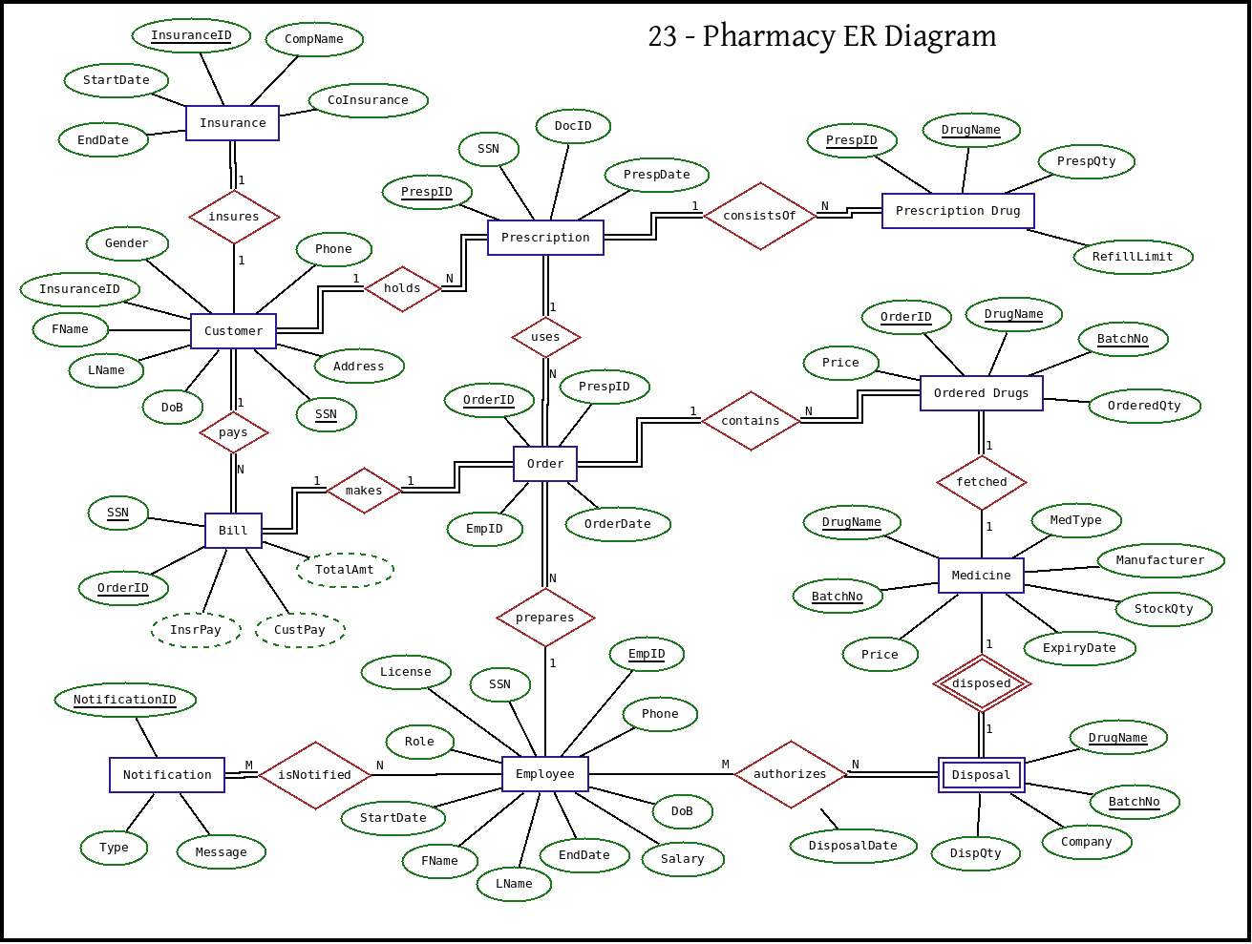

## Relational Schema

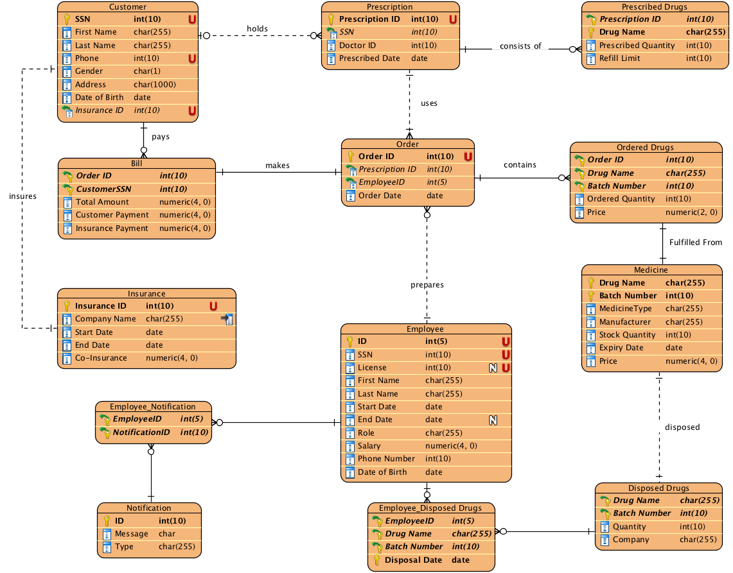

1. A single customer can have multiple prescriptions. Thus, the relation between them is one to many.
2. A prescription consists of multiple drugs, so the relation is one to many. In case of refills, a prescription can generate multiple orders. So, this relation is one to many as well.
3. A single order can contain multiple drugs, thus relationship is one to many. One order, however, can generate only one bill. Thus, the relation between bill and order is one to one.
4. A customer can make multiple purchases and hence, the relation between customer and bill is one to many. This is due to the fact that every bill has only one customer.
5. In medicine table (stock), drug name and batch number can uniquely identify every drug we have in inventory. Batch number is assumed to be unique among manufacturers.
6. Disposed drugs are weak entity and use foreign key Drug Name and Batch Number as their primary key.
7. One employee can receive multiple notifications and one notification can be sent to multiple employees, thus relationship is many to many.
8. Multiple employees can dispose same drug. Similarly, one employee can dispose multiple drugs. Hence, relationship is many to many.
9. One employee can prepare multiple orders. However, a specific order can only be prepared by one employee. Thus, relationship is one to many.

# Relations:

The final relations are listed below:

|  |  |  |  |  |  |  |  |
| --- | --- | --- | --- | --- | --- | --- | --- |
| **Customer** |  |  |  |  |  |  |  |
| SSN | First Name | Last Name | Phone | Gender | Address | Date of Birth | Insurance ID |

Primary Key: SSN

Foreign Key: Customer(Insurance ID) 🡪 Insurance(Insurance ID)

|  |  |  |  |  |
| --- | --- | --- | --- | --- |
| **Insurance** |  |  |  |  |
| Insurance ID | Company Name | Start Date | End Date | Co-Insurance |

Primary Key: Insurance ID

|  |  |  |  |  |  |  |  |
| --- | --- | --- | --- | --- | --- | --- | --- |
| **Employee** |  |  |  |  |  |  |  |
| ID | SSN | License | First Name | Last Name | Start Date | End Date | Role |
| Salary | Phone Number | Date of Birth | |  |  |  |  |

Primary Key: ID

|  |  |  |  |
| --- | --- | --- | --- |
| **Prescription** |  |  |  |
| Prescription ID | SSN | Doctor ID | Prescription Date |

Primary Key: Prescription ID

Foreign Key: Prescription(SSN) 🡪 Customer(SSN)

|  |  |  |  |
| --- | --- | --- | --- |
| **Prescribed Drugs** | |  |  |
| Prescription ID | Drug Name | Prescribed Quantity | Refill Limit |

Primary Key: Prescription ID, Drug Name

Foreign Key: Prescribed Drugs(Prescription ID) 🡪 Prescription(Prescription ID)

|  |  |  |  |
| --- | --- | --- | --- |
| **Order** |  |  |  |
| Order ID | Prescription ID | EmployeeID | Order Date |

Primary Key: Order ID

Foreign Key: Order(Prescription ID) 🡪 Prescription(Prescription ID), Order(Employee ID) 🡪 Employee(ID)

|  |  |  |  |  |
| --- | --- | --- | --- | --- |
| **Ordered Drugs** | |  |  |  |
| Order ID | Drug Name | Batch Number | Quantity | Price |

Primary Key: Order ID, Drug Name, Batch Number

Foreign Key: Ordered Drugs(Order ID) 🡪 Order(Order ID), Ordered Drugs(Drug Name, Batch Number) 🡪 Medicine(Drug Name, Batch Number)

|  |  |  |  |  |
| --- | --- | --- | --- | --- |
| **Bill** |  |  |  |  |
| Order ID | CustomerSSN | Total Amount | Customer Payment | Insurance Payment |

Primary Key: Order ID, Customer SSN

Foreign Key: Bill(Order ID) 🡪 Order(Order ID), Bill(Customer SSN) 🡪 Customer(SSN)

|  |  |  |  |  |  |  |  |  |  |  |  |
| --- | --- | --- | --- | --- | --- | --- | --- | --- | --- | --- | --- |
| **Medicine** | |  |  | | |  | |  | |  |  |
| Drug Name | | Batch Number | Medicine Type | | | Manufacturer | | | Quantity | Expiry Date | Price |
| Primary Key: Drug Name, Batch Number  **Disposed Drugs** | | | |  |  | |
| Drug Name | Batch Number | | | Quantity | Company | |

Primary Key: Drug Name, Batch Number

Foreign Key: Disposed Drugs(Drug Name, Batch Number) 🡪 Medicine(Drug Name, Batch Number)

|  |  |  |
| --- | --- | --- |
| **Notification** |  |  |
| ID | Message | Type |

Primary Key: ID

|  |  |  |  |
| --- | --- | --- | --- |
| **Employee_Disposed Drugs** | | |  |
| Employee ID | Drug Name | Batch Number | Disposal Date |

Primary Key: Employee ID, Drug Name, Batch Number, Disposal Date

Foreign Key: Employee_Disposed Drugs(Employee ID) 🡪 Employee (Employee ID), Employee_Disposed Drugs(Drug Name, Batch Number) 🡪 Disposed Drugs(Drug Name, Batch Number)

|  |  |
| --- | --- |
| **Employee Notification** | |
| Employee ID | Notification ID |

Primary: Employee ID, Notification ID

Foregin Key: Employee Notification(Employee ID) 🡪 Employee(ID), Employee Notification(Notification ID) 🡪 Notification(Notification ID)

# Database Creation

SQL commands for creating the tables in our database:

# Procedures

We have 3 stored procedure

1. Generate Bill
2. Report Expiring Drugs
3. Send Notifications

## Generate Bill

Making payments is slightly different in the pharmacy as customers may have insurance that supports co-payment. It means that insurance company pays a part of the bill while the patient pays rest of it. The data is stored in the database in the insurance table.

When the bill is generated, total amount is calculated based on ordered drugs and then copayment and customer payment is automatically calculated.

## Report Expiring Drugs

Any drugs that are going to expire within 60 days are displayed on screen along with their quantity and batch number.

## Send Notifications

Sending of notifications is recorded in “EMPLOYEE_NOTIFICATION” relation. We are assuming that a third party tool will pick notifications from there and send to the relevant employees. Email/Text is out of scope for the project.

# Triggers

We have a total of 3 triggers for following 2 tasks:

## Low Stock Alert

Low stock notification can be automatically sent when adding a medicine to the order makes the quantity too low for a medicine.

## Employee Validation

When an employee is added, the employee type should be one of:

1. Pharmacist
2. CPhT
3. Intern
4. Cashier

Except cashier, every other role requires a license.

# Conclusion

The pharmacy project was a good learning experience for implementing a real world DBMS and helped us understand the nuances of a full implementation.

The most interesting part was the experience of starting from real world and then translating the concepts into the terms of a DBMS. The final implementation is robust and can handle various edge cases and scenarios. Paired with a capable application front end, it can handle day to day operations for a pharmacy.

**Acknowledgement**

Above all the praise goes to ALMIGHTY ALLAH with whom all the sovereignty, WHO bestowed us the essence of knowledge and the sight to differentiate between the right & wrong.

We will greatly like to thank our teacher, **Dr. Farrukh Arslan** who assigned us this project to enhance our knowledge and information regarding this course “Database Engineering”.

**Thank You**